Solutions To:
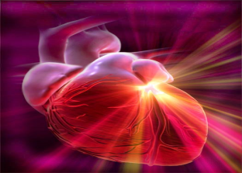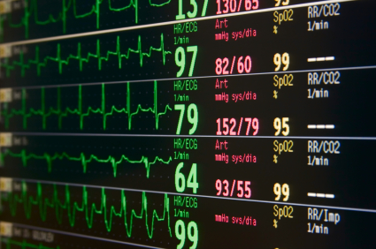
Cardiovascular Mini Case Studies
 | PAGES:
*Case Study I: | (2-8) | 60 Y.O. Man, SOB, “Palpitations”
*Case Study II: | (9- 15) | 67 Y.O.woman,‘heart skipping beats’,‘check-up’
*Case Study III: | (16-19) | 46 Y.O. Woman, ‘heart skipping beats’
*Case Study IV: | (20-25) | 37 Y.O. Man, Acute Inferior Myocardial Infarction
*Case Study V: | (24-27) | 30 Y.O. Man, “Vague Chest Pain, ‘fluttering feeling’
*Case Study VI: | (28-33) | 16 Y.O. Girl with ‘palpitations & dizziness’
*Case Study VII: | (34-36) | 42 Y.O. Woman. ‘palpitations & dizziness’
*Case Study VIII: | (37-39 | 30 Y.O Woman ‘fluttering in chest’
*Case Study IX: | (40-43) | 70 Y.O. Man. ‘Fatigue, dependent edema, s.o.b.
*Case Study X: | (44-50) | 20 Y.O. Woman. Multi-Trauma; MVC

Case Study I 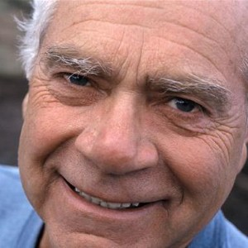
Mr. G. is a 60 year old male. He has a history of paroxysmal atrial dysrhythmias and has been placed on metoprolol for rhythm control, but is generally nonclompliant with his medication.
Mr. G. is independent, lives alone, and holds a high level position with a local software company. Recently, he came to the ED with complaints of shortness of breath, dizziness, and intermittent "palpitations".
Physical Assessment:
Neuro: AAO x 3, follows commands, moves all extremities equally. Complains of intermittent dizziness, especially when he is standing.
Pulmonary: Respirations rapid, lungs clear in all lobes.
GI: Normoactive bowel sounds. Complains of nausea.
GU: Normal; denies changes in frequency or urine color.
CV: Pulse slow & regular, thready, nailbeds blue, circumoral cyanosis, capillary refill >3 seconds; peripheral pulses present, but weak. Denies chest pain.
Vitals: HR- 44 and regular, Respiratory rate 28, BP 92/50, Temp. 98 F, SaO2 90% on room air

History:
Mr. G states that he is just recovering from a serious episode of the flu. He has experienced diarrhea and vomiting for several days. He began feeling better and resumed his medications and went back to work.
Medications:
Metaprolol 50 mg po, daily
Diagnostic studies:
CXR: Normal
Labs: Na 135, K 3.0, BUN 27, Creat. 1.4, FBS 100

EKG rhythm strip:
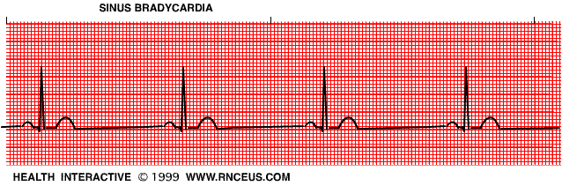
8 big blocks= 8 x 0.2 sec= 1.6 sec
60/1.6= 37.5 = 38 beats/minute

1. Identify the dysrhythmia.
Top of Form
- 2nd degree, Mobitz I heart block
- 1st degree AV block
- Normal Sinus Rhythm
- Sinus Bradycardia

2. What is this patient’s ventricular rate and rhythm?
a. 34, regular
b. 37, regular
c. 42, irregular
d. 55, regular

3. Is the patient symptomatic, or asymptomatic?

- Symptomatic
- Asymptomatic

4. Pharmacotherapy for this patient, based upon his condition and symptoms, would include:

- Adenosine, 6 mg IV Push
- Adenine sulfate, 50 mg po
- Atropine sulfate 0.5 mg IV
- Adrenaline 1 mg IV Push

A few minutes after the appropriate medication is administered (per the above question), the patient’s rhythm strip is the following:
Rate =0.72 x 60= 83 bpm

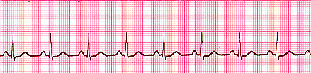

5. As this patient’s primary nurse, you recognize this rhythm as:

- Sinus tachycardia
- First degree AB Block
- Atrial fibrillation
- Sinus rhythm

6. After seeing the above rhythm on the patient’s monitor, what does he or she need to do now?

- Administer a second dose of adenosine
- Assess the patient: Vital signs, level of consciousness, skin color, and more.
- Administer a second dose of atropine, 1 mg IV push
- Transfer the patient to ICU

7. Ten minutes after the above strip, the nurse sees the following on the patient’s monitor:

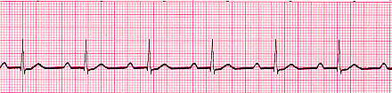
PR Intervals all equal (PRI)=0.32

7. After reviewing this strip, the nurse correctly identifies the rhythm as:

- Sinus tachycardia
- First degree AV Block
- Atrial fibrillation
- Normal Sinus Rhythm

8. Treatment for this change in patient condition would include:

- Continue to monitor the patient closely
- Notify the primary care provider
- Administer adenosine 6 mg IV push
- A and B
- A, B, and C

9. Ten minutes later, the nurse saw the following rhythm on the monitor: The nurse correctly identifies this rhythm as:

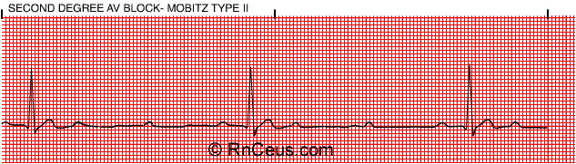

- 2nd degree AV Block, Mobitz II
- 1st degree AV Block
- asystole
- Torsades de pointes (atypical ventricular tachycardia)

10. Based upon the above information, what should the nurse do next?

- Administer a second dose of adenosine, IV Push
- Assess the patient: Vital signs, level of consciousness, skin color, and more.
- Administer a second dose of atropine, 1 mg IV push
- Transfer the patient to ICU

11. The above patient has the following clinical data: BP=88/40, P=30, R=32, SaO2=86% RA. Confused and showing sign of a feeling of impending doom. The nurse should prepare for the following:

- Temporary pace maker (transcutaneous application) followed by (possibly) permanent pacemaker insertion
- Defibrillation followed by cardioversion
- Since you want to slow down conduction through the AV Node, Administer an antiarrhythmic such as amiodarone or lidocaine IV Push, followed by a continuous infusion of the antiarrhythmic
- Do nothing other than to continue to closely monitor this patient

Case Study II
J. D. is a 67 year old female with a history of CHF. She also has a history of having a tricuspid valve insufficiency, with associated grade II murmur. She is an ex-smoker and has committed to living a healthy lifestyle. She is careful with her diet and exercise and her goal is to be able to discontinue her cardiac medications. J.D. believes that if she can get back into shape, her body will no longer require medical intervention.
J. D. has been noticing an increase in shortness of breath when doing simple tasks around the house and also has noticed some "heart skipping". She comes to the clinic for a check-up.
Physical Assessment:
Neuro: AAOx 3, moves all extremities to command, and exhibits equal strength.
Pulmonary: Exhibits shortness of breath when walking; lung auscultation reveals bilateral crackles in the bases.
GI: Bowel sounds normal; abdomen is non-tender to palpation.
GU: Clear yellow urine, no abnormalities.
CV: Pulse irregular, nailbeds pink, peripheral pulses strong. 2+ edema in lower extremities
Vitals: HR 90-95, Respiratory rate 30, BP 156/88, Temp 98.4 F, Weight 165 (note: her weight has increased by 15 lb since her last check up 1 month ago).
History: J.D. states that she discontinued her digoxin and her lasix last week because she felt like she didn’t need them anymore.
Medications: Digoxin 0.125 mg PO qd
Lasix 40 mg PO qd
KCL 20mEg PO qd
Multivitamin PO qd
ASA 80mg PO qd
Diagnostic Studies:
CXR: reveals a right lower lobe pleural effusion.
Labs: Na 137, K 2.8, BUN and Creatinine normal.
EKG rhythm strip:
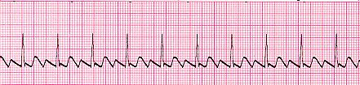

- Identify the dysrhythmia :

Top of Form

- Atrial fibrillation
- Atrial flutter
- Ventricular fibrillation
- Sinus arrest

- Based upon the assessment data, and the ekg strip, What might be an appropriate treatment for J.D.?
- IV digoxin and Lasix
- Defibrillation
- Temporary pacing
- Magnesium sulfate, IV

3. Which are appropriate nursing assessments or interventions for this patient?
a. Assess for L.O.C., responsiveness, vital signs

b. Place patient in Trendelenburg position due to possible cardiac output problem, as well as potential shock.
c. No interventions or assessments are necessary at this time.
d. Prepare to administer adenosine 6 mg IV Push.

4. The "hallmark" of the dysrhythmia is:
- Regularity
- Saw tooth baseline
- Wide, bizarre QRS complexes
- Irregularly irregular rhythm

5. The PR interval in the dysrhythmia is:
a. prolonged
b. normal
c. not measurable
d. shortened

6. Based upon her history of tricuspid insufficiency, at which of the following anatomical sites would the nurse auscultate to best assess the tricuspid valve?tricuspid valve insufficiency, with associated grade II murmur, which site below is the correct spot to auscultate this murmur, i.e., hear the tricuspid valve?

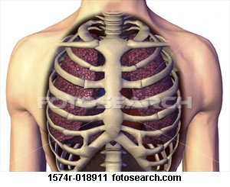
5
4
3
2
1
- 1
- 2
- 3
- 4
- 5

7. J.D. is sent to the hospital for admission to the telemetry unit, for close observation. During the admitting nurse’s assessment of J.D.,it is noted that the cardiac monitor pattern changes, and the following strip is recorded. Analysis of the strip reveals that the rhythm is:

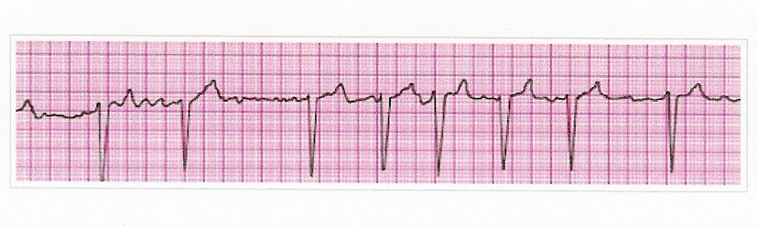

- Ventricular fibrillation
- Atrial flutter
- Sinus tachycardia
- Atrial fibrillation

8. Based upon this change in the patient’s cardiac monitor assessment data, what should be the nurses’ first action?

- Assess the patient for level of consciousness, chest pain, or any other changes in condition.
- Prepare to administer vagal maneuvers
- Administer adenosine, 6 mg, IV Push
- Prepare to administer an antiarrhythmic such as amiodarone or lidocaine, followed by a continuous infusion of that antiarrhythmic.

9. 45 minutes after the above rhythm commenced, the patient is complaining of shortness of breath. Vital signs: BP 138/86, P=136, R=28, SaO2= 90%. Patient has +JVD at 45* HOB, and coarse crackles in all lung fields. Based upon this data, what should the nurse conclude?

- Patient is about to go into ventricular fibrillation
- This is a normal turn of events for this particular problem
- The patient will get better as long as she is closely monitored and observed
Pt has sx of both R & L side heart failure. HOWEVER, selection D is the only possible answer of the four choices.
“Arguable”
- The patient has right sided heart failure, based upon the symptoms.

10. One hour after the above, the primary care physician is on the way to the hospital, but gave no orders other than to continue monitoring the patient. The patient is becoming increasingly disoriented, and the right pupil is 6 mm and sluggishly responds to light, as opposed to the left pupil, which is 3 mm and responds briskly to light. Based upon these assessment findings and the patient’s history, the nurse suspects:

- Intracranial hemorrhage
- Embolic CVA
- Hypoxia due to the heart failure
- Impending cardiac arrest

Case Study III 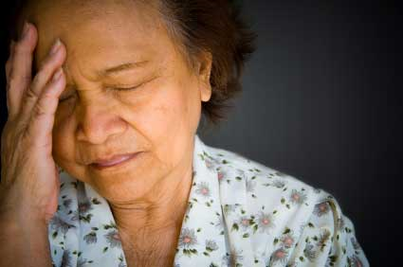

Ms. M. M. is a 46 year old executive for a high profile accounting firm. She spends much of her time behind the desk working on her computer. Ms. M.M. states that recently her job has become more stressful and lately she has noticed her heart "skipping a beat" every now and then.
Ms. M. M. smokes cigarettes 1ppd and drinks at least 5 cups of coffee during the day. She states she is tired of being overweight and is taking an herbal diet pill. Ms M. M. states that she has not been sleeping well lately due to increased stress at her job.
Physical Assessment:
Neuro: AAOx3, follows all commands and exhibits equal strength in all extremities.
Pulmonary: Bilateral breath sounds with decreased bases. Ms. M. M. tells you she has a "smoker’s cough" in the mornings.
GI: No complaints, abdomen soft, nontender with active bowel sounds.
GU: Denies any GU problems. Exhibits clear, yellow urine.
CV: Slightly irregular heart rate. Pulses strong in all extremities, no edema, nail beds pink, and heart sounds are normal s1 and s2.
Vitals Pulse 88, BP 154/88, Respiratory rate 22, temp. 98.4 F. Height 5’4", weight 182 lb.
History Ms. M.M. has been smoking 1ppd for the past 10 years. She states she tried to quit, but just kept gaining weight. Ms M. M. began taking herbal diet pills 2 weeks ago in an attempt to lose weight. She doesn’t like to exercise because it is "embarrassing".
Medications: Ms. M.M. states that she takes an OTC herbal weight loss supplements that the sales clerk said is "just as good or better than ephedra". She states that she takes 1 tablet QID.
Diagnostic studies:
CXR: normal,
Labs: Blood chemistry and hematology are normal.
EKG rhythm strip:
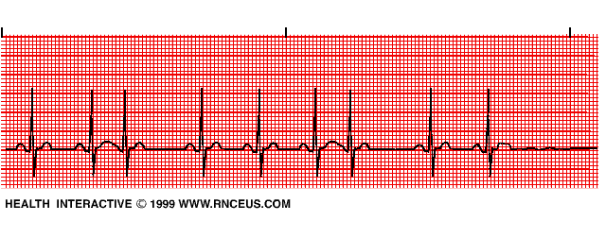
- The name of the cardiac rhythm on Ms. M. M.'s EKG is:
- Sinus rhythm with PVCs
- Sinus rhythm with PACs
- Wandering atrial pacemaker
- Atrial fibrillation

- The cause of this rhythm might be:
- Caffeine
- Tobacco
- Herbal diet pills
- Any or all of the above

- The treatment of choice for this rhythm is:
- Cardioversion with low joules
- Epinephrine
- Correct or eliminate the underlying cause
- Lidocaine IV Push to treat PVCs

- The seriousness of this rhythm is:
- Lethal dysrhythmia
- Very serious
- Normal
- Continued assessment is warranted

- Nursing care for Ms. M. M. includes:
- Counsel Ms. M.M. about the benefits of smoking cessation
- Diet and exercise counseling
- Stress reduction
- All of the above

Case Study IV

Mr. T, a 37 year old male, is admitted to the ICU after suffering an acute inferior MI. At this moment he is pain free, but has required sublingual nitroglycerine and morphine for pain control in the emergency department.
Physical Assessment:
Neuro: Sleepy, but rouses easily to voice. AAOx3. Exhibits equal strength in all extremities.
Pulmonary: Lungs are clear. Resp. even and unlabored. Mr. T. is on O2 via nasal cannula at 2L/min.
GI: Bowel sounds normal, abdomen soft and nontender.
GU: Voiding clear yellow urine without problems.
CV: Heart sounds normal with S1 and S2 present. Nail beds pink with good capillary refill. Denies chest pain at this moment.
Vitals: HR: 90, BP 102/55, Resp. 16, Temp. 97.2 F, Height 6’0", Weight 210 lb.
History:
Mr. T. is a construction worker and states he is active and normally healthy. He has been having episodes of chest pain for the past 3 months, but thought it was just "gas" and didn’t go his physician. Mr. T. is a past smoker and has been cigarette free for the past 12 months. He states he has a few beers with his buddies after work sometimes.
Medications: Tums 2 tabs prn prior to this admission.

Diagnostic Studies:
CXR normal, Coronary angiogram shows a lesion in the left coronary artery.
Labs: CK, isoenzymes and troponin levels are elevated, K+ 3.6, Na+ 145, BUN and Creatinine are normal. Cholesterol 250.
During the acute phase of Mr T’s hospitalization, his cardiac monitor showed the rhythm / evidence below.
- What on that rhythm strip stands out, identifying a probable myocardial infarction?
- Rate is very slow
- ST Segment Elevation
- Wide QRS complexes
- Tall tent-like T waves
EKG Strip Number 1:
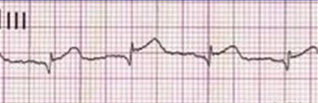

- In terms of diagnostic tests, which of the following would be most indicative of cardiac tissue damage associated with a myocardial infarction?
- LDH
- CDC
- Troponin
- Potassium

A later cardiac rhythm strip on Mr T., two days after admission:
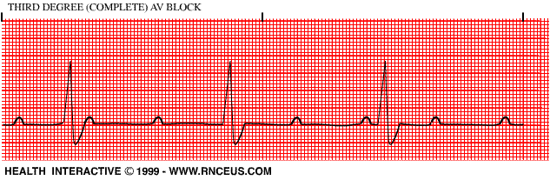

- What is the above rhythm?

a. Sinus Rhythm
b. 1st Degree AV Block
c. 2nd Degree AV Block, Mobitz I (Wenkebach)
d. 3rd Degree Av Block

- Treatment for Mr. T. might include:

a. Prepare to administer an antiarrhythmic such as Lidocaine
b. Prepare for temporary pacemaker, possibly permanent pacemaker
c. Prepare to administer a bolus of KCl
d. Prepare to transfer to the telemetry floor

- This rhythm:

- Is Always fatal
- Is Normal under the circumstances
- Is Often accompanies low potassium levels
- Requires a pacemaker

- Nursing care for Mr. T includes:

- Continued EKG Monitoring
- Aiding in measure to increase cardiac output
- Relieving his anxiety
- All of the above

Case Study V

Mr. V. W., a 30 year old triathlete and long distance runner, came to the ER complaining of vague chest pain and frequent palpitations after his daily run today. His health history is negative except for a fractured ankle last year after a bike accident. Mr. V. W. denies ever having chest pain in the past.
Physical Assessment:
Neuro: AAOx3, equal strength in all extremities.
Pulmonary: Resp. slightly labored. Lungs clear in all lobes.
GI: Normal bowel sounds, complains of some nausea.
GU: Voiding large amounts of clear, pale yellow urine without difficulty.
CV: Pulse irregular, Heart sounds S1 and S2, peripheral pulses strong in all extremities.
Height: 6’0, Weight: 165
History: Mr. V.W. has just recently moved from California to Southern Nevada. He remarks about the heat. Mr. V.W. also states that he noticed that he had weight gain of 10 pounds since his move and this concerns him. He also tells you that he believes his weight gain is due to an increase in "water" and he borrowed a couple of his mother’s "water pills" to try and reduce his weight.
Medications: Multivitamin 1 qd
Herbal energy supplements 2 -3xd
Lasix 40 mg x 2 (borrowed from his mother)

Diagnostic studies:
CXR: normal

Labs: Na 131, K+ 3.0 . All other labs within normal limits.
EKG rhythm strip:
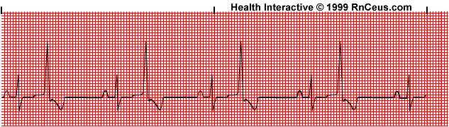
- The rhythm Mr. V.W. is experiencing is:
When every other beat is normal, and every other beat is a PVC, it is oftentimes called Bigeminy. Whatever the case, the patient is having frequent, unifocal PVC’s!
- Sinus rhythm with PACs
- 2nd degree AV Block, type II
- Ventricular bigeminy
- Atrial flutter

Bottom of Form
Top of Form
Bottom of Form
- The cause of the rhythm could be:

- Too much exercise
- Electrolyte imbalance
- Stroke (CVA)
- Nerve damage
Top of Form
Bottom of Form

- Treatment for the above rhythm might include:

- Oxygen
- Correction of electrolyte imbalance
- Lidocaine
- All of the above
Top of Form
Bottom of Form

- The premature beats in the rhythm occur:

- In the atria
- In the SA node
- In the AV node
- In the ventricles

Bottom of Form
Top of Form
Bottom of Form
- Other causes of the above rhythm (not including Mr. V. W.’s problem) are:

- Myocardial ischemia
- Digitalis toxicity
- Increase in circulating catecholamines
- All of the above

Case Study VI 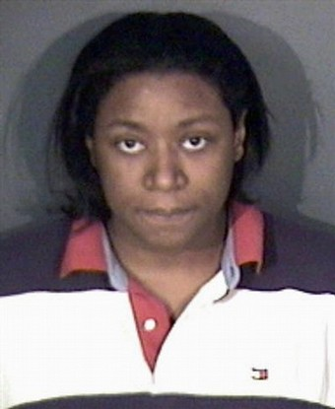

Jamey, 16 year female, is admitted to your unit for complaints of palpitations and dizziness. On admission she had no symptoms complaints, but right after your shift starts she calls and tells you her palpitations are starting again. She is very anxious.
Physical Assessment:
Neuro: AAOx3, perrla, exhibits restlessness and complains of anxiety.
Pulmonary: Lungs clear to auscultation in all lobes. Respiratory rate rapid.
GI: BS active x 4 quadrants, abdomen soft and non tender.
GU: Voiding clear yellow urine in adequate amounts.
CV: Heart sounds rapid S1S2, good capillary refill, peripheral pulses 2+, complains of palpitations.
Vital signs: Pulse 160, BP 100/64, Resp. rate 28, temp 98.7 F
History: James is a normally healthy teenager. He is active in track sports and does not smoke or consume alcohol. He states that the palpitations and dizziness started about a month ago and he experiences episodes once or twice per week.
Diagnostic studies: Na+ 140, K+ 3.4, BUN and creat normal, Cardiac markers all normal.

EKG rhythm strip:
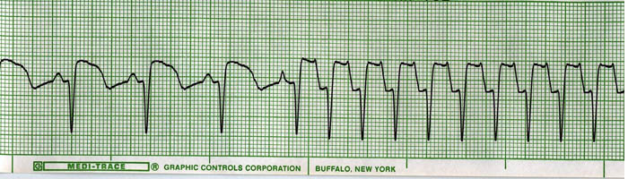
1. What rhythm is this?
Top of Form
- Ventricular tachycardia (VT)
- Supraventricular tachycardia (SVT)
- Normal sinus rhythm
- Atrial fibrillation

Bottom of Form
Top of Form
Bottom of Form

2. Which of the following medications would be appropriate for this dysrhythmia?
Top of Form
- Atropine
- Lidocaine
- Adenosine
- Vasopressin

Bottom of Form
Top of Form
Bottom of Form
- This dysrhythmia is most common in teenagers and young adults.

a. True
b. False

Top of Form

Bottom of Form
Top of Form
Bottom of Form
4. Nursing care for Jamey would include?
Top of Form
- Frequent cardiovascular assessment
- Psychosocial support
- Education for James and his family
- All of the above

Bottom of Form
Top of Form
Bottom of Form
5. An interventional technique to eliminate this dysrhythmia is:
a. Vagal Maneuvers
b. Cardiac stenting
c. Thrombolysis
D. Coronary artery bypass grafts

6. When any appropriate intervention technique is used for this individual, what equipment should be readily available to the treatment team?
a. crash cart and resuscitation equipment
b. cardiac cath lab
c. an ambulance
d. Cardiac stents and angioplasty equipment

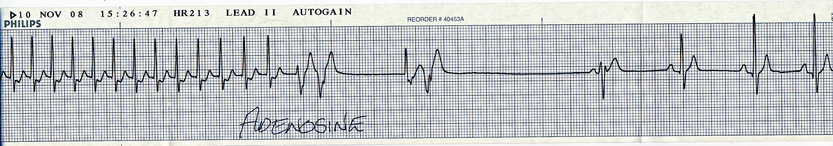
Adenosine 6 mg IVP

Adenosine, 6 mg is administered via the IV bolus route.

Immediately after the above strip, the patient is awake and alert, She is voicing no complaints.

Five minutes after the above rhythm strip, the patient displays the following rhythm on the cardiac monitor:

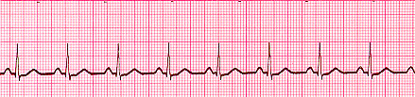

- Based upon the strip above, the nurse should:

- Assess the patient for responsiveness, BP, Pulse
- Chart that the patient has successfully converted to sinus rhythm
- Prepare the patient’s scheduled medications
- Administer another dose of epinephrine IV push as soon as possible

- Assessment of this patient yields: patient is unresponsive; no pulse can be palpated or auscultated; blood pressure =0. The rhythm in the strip above continues to be displayed on the monitor. Based upon this, the nurse knows that this rhythm is:

- Sinus rhythm (NSR)
- Pulsesless electrical activity (PEA)
- Ventricular fibrillation (VF)
- Sinus tachycardia (ST)

- Treatment for this rhythm includes:

- Find and elimate the source
- Administer Lidocaine IV push
- Administer Amiodarone IV push
- Apply alternating tourniquest to equalize blood pressure

Case Study VII 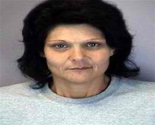

Jenny, a 42 year female, is admitted to your unit for complaints of palpitations and dizziness. On admission she had no symptoms complaints, but right after your shift starts she calls and tells you her palpitations are starting again. She is very anxious.
Physical Assessment:
Neuro: AAOx3, perrla, exhibits restlessness and complains of anxiety.
Pulmonary: Lungs clear to auscultation in all lobes. Respiratory rate rapid.
GI: BS active x 4 quadrants, abdomen soft and non-tender.
GU: Voiding clear yellow urine in adequate amounts.
CV: Heart sounds rapid S1S2, good capillary refill (< 3secs), peripheral pulses 2+, complains of “palpitations.”
Vital signs: Pulse 170, BP 90/58, Resp. rate 28, temp 98.7 F
History: Jenny is a fairly healthy adult. She is active in sports, but does smoke 1-2 ppd, and consumes alcohol “socially.” She has a very high stress job as nursing director of a Cardiovascular ICU. She states that she has had the palpitations a couple of times previously, but they disappeared spontaneously.
Diagnostic studies: Na+ 140, K+ 3.4, BUN and creat normal, Cardiac markers all normal.

EKG Rhythm Strip:
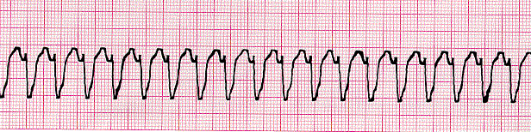

- What rhythm is this?

- Ventricular tachycardia
- SVT (Supraventricular tachycardia)
- Sinus tachycardia
- Atrial fibrillation

- Which of the following medications would be appropriate for this dysrhythmia?

- Atropine IV push
- Lidocaine IV push
- Adenosine IV push
- Vasopressin IV push

- Since this rhythm is associated with consciousness and a pulse, the correct treatment for this dysrhythmia might be:

- Defibrillation
- CPR
- Synchronized cardioversion
- Precordial thump

- The seriousness of this rhythm is:

s. lethal
b. Very serious
c. normal
d. Continued assessment is warranted

Case Study VIII

Ms G. is a 30 year old woman who reports to the Emergency Department with a complaint of ‘a fluttering feeling in her chest for several minutes. She states that she has had this problem before, but that ‘it always went away, before.’
Ms. G. is independent, lives alone , and holds a high level position in a local software company. Right now Ms. G. complains of shortness of breath, dizziness, intermittent palpitations, and light-headedness, especially immediately after standing up.

Physical Assessment:
Neuro: AAO X 3, follows commands, moves all extremities well. C/O intermittent dizziness.
Pulmonary: Respirations rapid, lungs CTA all lobes
GI: BS Normoactive 4 quadrants
GU: No complaints, states on OCP; menses regular—has not skipped!
Vitals signs: HR 140, R 28, T 98*, SaO2=96%

History: No medications other than OCP’s; essentially negative medical history. Admits to 1 ppd cigarettes x 10 years, ‘several Starbuck’s Mega Lattes each day. Denies drug use; drinks ‘every week end.’

Medications:
Oral Contraceptive Pills
Multivitamins
Herbal Medicine (otc): Gingko Biloba
?? (forgot name)‘helps me concentrate’

Diagnostic Studies:

Urine HCG (pending)
Na 138 K 4.2 BUN 23 Creat 1.4 FBS 88

EKG Rhythm Strip:

The patient has a narrow complex tachycardia; ventricular rate is 144; QRS’s are < 0.12 seconds and all look alike; p waves are present, but hard to identify due to the ventricular rate.

1. Based upon the description provided, Identify the dysrhythmia / arrhythmia:
a. atrial fibrillation
b. ventricular fibrillation
c. asystole
d. ventricular tachycardia
e. supraventricular tachycardia
f. torsades de pointes
g. sinus tachycardia

2. What are possible causes of this patient’s dysrhythmia? (choose all that apply)
a. caffeine
b. nicotine
c. illicit drugs
d. stress
e. low serum potassium
f. tumor on the adrenal glands
g. anxiety
h. high serum potassium
i. pain
I left out a rhythm strip showing that the rate was regular, with a ventricular rate of 168=SVT. SO, treatment for SVT, not sinus tachycardia, is warranted. (My Bad!)
3. Prioritize the treatments for this dysrhythmia, from non-aggressive (lower risk=1) to aggressive (higher risk=3) Leave the space blank if the choice would not apply to this patient:
__. Adenosine IV Push
__. Vagal maneuvers
__. Synchronized cardioversion
__. Identify the source & eliminate, if possible.
__. Administer oxygen as ordered

4. What is the prognosis for Ms. G?
a. Good, once the rhythm is corrected
b. Poor, since this is a lethal dysrhythmia.
c. Good, after surgery
d. Poor, since this is a condition that deteriorates

MAXI CASE STUDY IX

You are working in the internal medicine clinic of a large teaching hospital. Today your first patient is 70 y.o. J.M., a man who has been coming in to the clinic for several years for management of CAD, HTN, and anemia. A cardiac catheterization done a year ago showed 50% occlusion of the circumflex coronary artery. He has had episodes of dizziness for the past 6 months, and orthostatic hypotension, shoulder discomfort, and decreased exercise tolerance for the past 2 months. On his last visit 3 weeks ago, a chest xray and 12-lead EKG were done, showing cardiomegaly. Results of chemistries drawn at this time were as follows:

Na 136, K 5.2, BUN 15, Creatinine 1.8, glucose 82, Cl 95;

Results of CBC : WBC 4.4 thousand, Hgb 10.5, Hct 31.4%, plts 229,000.

This morning his daughter has brought him to the clinic because he has had an increase in fatigue, significant swelling in the ankles, and SOB x 2 days.

Vital Signs:
142/86, 115, 26, 99.2*, O2 Sat 88%/RA

Rhythm Strip:

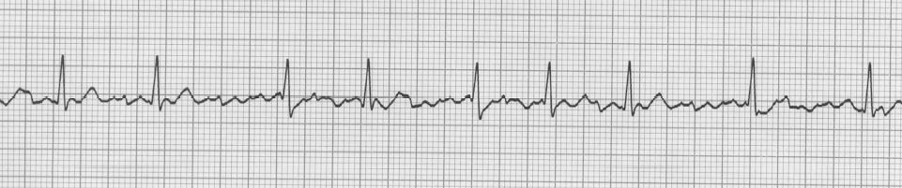

- This rhythm is:

  - Ventricular tachycardia
  - Ventricular fibrillation
  - Atrial flutter
  - Atrial fibrillation

- This patient ventricular rate and rhythm is:

  - 90’s, irregular
  - 60’s, regular
  - 84, regular
  - 110, irregular

You escort the client into an exam room and conduct a more detailed physical assessment.
:

Pertinent findings:

Lungs : coarse crackles , all lobes.
+ JVD with HOB elevated 30 degrees
Liver palpable 4 “ below right costal border
3+ Pitting edema, feet and ankles up to mid-thigh

Heart Sounds: S1, S2, +S3

1. Based upon your assessment findings, you suspect:

- MI
- (L) sided heart failure
- (R) sided heart failure
- Both sides heart failure

END OF THE EXERCISE FOR Block 7.0 !

List NINE ITEMS on your physical assessment to confirm your above diagnosis.

1
2
3
4
5
6
7
8
9

Write a concept map and nursing care plan for this client (as an inpatient).

INCLUDE MED DX, 5 Nursing Diagnoses (including DX, R/T, and AEB)

INCLUDE KEY ASSESSMENTS (see the concept map in one of this week’s Power Points).

WORK UP EACH NURSING DIAGNOSIS to include at least 3 nursing interventions. Include evaluation planning.

CASE STUDY X

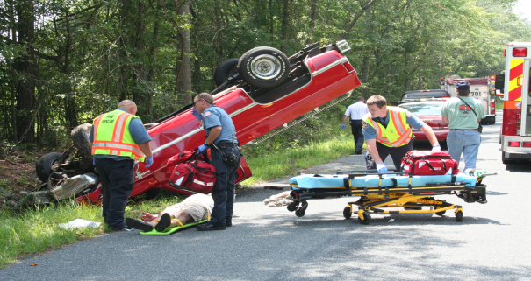
Case Study # 10:

Jane House is 20 years old, and was admitted to the ER following a motor vehicle crash (MVC) earlier in the day. She was an unrestrained passenger in an automobile that was T-boned by another vehicle on her side of the car. She was pinned in the wreckage for 30 minutes, and was finally brought in by emergency transport helicopter. She suffered a partially severed leg, a chest contusion possible fractured pelvis, open head wound, and fractured jaw. She has lost several units of blood. She has been in post-anesthesia care unit (PACU) for the past hour following surgery to reattach her leg and close her head wound. Her vital signs have been stable. The nurse enters the room to find Mary’s NG draining copious amounts of sanguineous fluid.

Focus Questions:

1. Relate your client’s current manifestations to the pathophysiology of shock to determine what type of shock the client could be experiencing.

2. Apply principles of collaborative care for clients experiencing shock to determine what the nurse’s initial response should be, and why. (What nursing interventions are universal for any client with shock?)

Discussion:

The major focus of emergency care of the client is maintaining or restoring a level of tissue perfusion to sustain life.

Assessment is always the initial action in the nursing process.

**Obtain Vital Signs and an initial physical assessment
**Maintain a patent airway
**Initiate oxygen administration
**Obtain IV access

ADDITIONAL INTERVENTIONS ARE SPECIFIC TO THE TYPE OF SHOCK

Jane House (DATA):

Vital Signs: T=98*,
P=120, thread, rapid ,
R= 30,
BP= 80/60
Skin: Moist, cool, pale, with dependent edema

Focus Questions:

3. With this additional data, do you agree with your original interpretation of the kind of shock the client is experiencing? Why or why not?

4. Based upon new data, what type of shock is the client experiencing?

5. What stage of shock is your client in?

6. What would be the expected laboratory tests for each client?

7. Apply principles of collaborative care for clients experiencing shock to determine what are –in general—and specific to each client, the expected medical / pharmaceutical treatments / interventions.

Discussion:

Standard Management for All Classifications of Shock:
The focus on nursing care for the client in shock is assessing and monitoring tissue perfusion and meeting the psychosocial needs of the client and his or her family.

Assessment begins with a history and a physical assessment. A history of the client’s presenting problem will provide clues in determining the causative factors and the type of shock.

Assessments specific to all classifications of shock:

--Vital Signs
--Level of consciousness
--Skin turgor, temperature, moisture or dryness, and color
--I&O
--Hourly urine output and urine color
--Peripheral pulses
--Hemodynamic monitoring of arterial, pulmonary artery, and central venous pressures.
--Bowel sounds and abdominal distention

Interventions specific to all classifications of shock:

--Establishing and maintaining a patent airway and adequate oxygenation with oxygen therapy by mask, nasal cannula, or endotracheal tube.
--Obtaining intravenous access through two large-bore peripheral lines or a central line
--Inserting a foley catheter in order to monitor hourly urine output
--Maintaining bed rest.

Focus Question:

8. Discuss the nursing implications for treatments and medications prescribed for these clients in shock:
**Hypovolemic shock: rapid administration of fluids without compromising the pulmonary circulation; fluids given too rapidly could cause pulmonary edema and congestive heart failure.

**Specific nursing responsibilities with the administration of colloids and crystalloid solutions include:
**Establish baseline vital signs, lung sounds, heart sounds, central venous pressure, and pulmonary artery wedge pressure
**Monitoring and recording vital signs every 15 minutes until stable
**Monitoring and recording hourly urine output
**Monitoring for signs of congestive heart failure or pulmonary edema: dyspnea, cyanosis, cough, crackles, or wheezes.
**Monitoring for signs of dehydration: dry lips, dark-colored urine, and urinary output of less than 30 ml / hour
**Monitoring for signs of circulatory overload: jugular vein distention, increased CVP, increased pulmonary artery wedge pressure
**Monitoring prothrombin, partial thromboplastin times, and platelet counts
**If administering dextran or plasma protein fraction, having epinephrine and antihistamines available for any signs of hypersensitivity, such as fever, chills, rash, headache, wheezing

**Specific nursing responsibilities with the administration of blood and blood products include:

**ALL OF THE MEASURES UNDER CRYSTALLOID AND COLLOID SOLUTIONS
**Assessing for previous blood reactions
**Using blood administration tubing and initiating a saline solution administration to flush the tubing and filter
**Administering the blood immediately
**Checking and documenting / verifying correct blood unit for correct client
**Checking the compatibility of blood type and Rh factor
**Checking the expiration date on the blood
**Checking the unit for bubbles or discoloration
**Taking and recording the vital signs prior to administering the blood
**Initiating the infusion rate at 2 mL per minute for the first 15 minutes
**Monitoring the client for hypersensitivity or hemolytic reactions and taking and recording vital signs per agency protocol
**After first 15 minutes, if no adverse reactions, increasing the rate of administration to ensure the whole unit of blood infuses within 3-4 hours.
**Immediately stopping the infusion if any adverse reaction occurs
**Keeping the vein open with saline
**Taking and recording vital signs
**Returning the blood and tubing to the lab
**Following agency protocols for collecting urine and blood specimens
**Continuing to monitor the client

