Practice ECG Strips

Directions: Many of these strips are for more advanced EKG Interpretation, so do not be disheartened if you do not know the answers! The purpose for our work here today is for you to go through the steps of EKG strip analysis, e.g., determine the overall impression, then go through the steps of identification and analysis: determine rate, rhythm, P wave analysis, PR Interval measurement, QRS duration measurement, and more. Finally, go through the ordered steps of analysis, and answer as many of the questions as you can!

All leads are Lead II
(unless otherwise noted…)

ECG #1
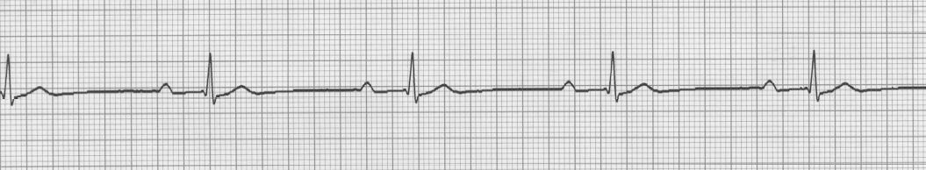

Rate: ____________________________________
Rhythm: ____________________________________
P waves: ____________________________________
PR Interval: ____________________________________
QRS: ____________________________________

Dx: ____________________________________________

ECG #2
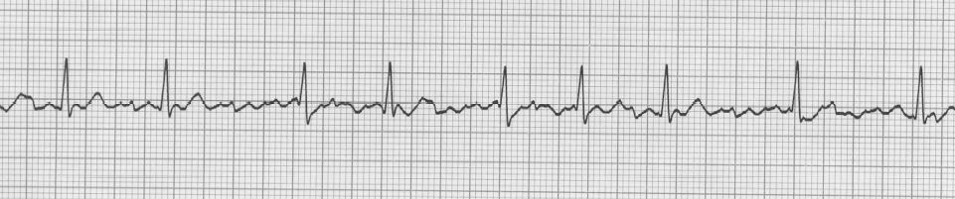

Rate: ____________________________________
Rhythm: ____________________________________
P waves: ____________________________________
PR Interval: ____________________________________
QRS: ____________________________________

Dx: ____________________________________

ECG #3
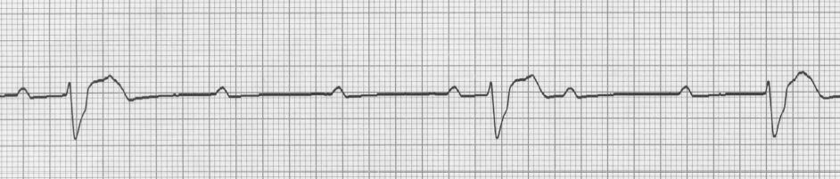

Rate: ____________________________________
Rhythm: ____________________________________
P waves: ____________________________________
PR Interval: ____________________________________
QRS: ____________________________________

Dx: ____________________________________

ECG #4
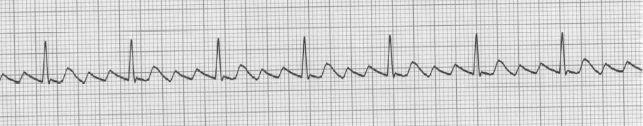

Rate: ____________________________________
Rhythm: ____________________________________
P waves: ____________________________________
PR Interval: ____________________________________
QRS: ____________________________________

Dx: ____________________________________________

ECG #5
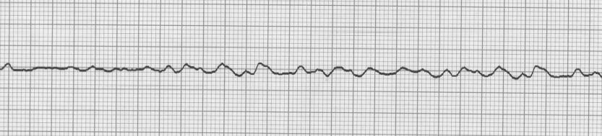

Rate: ____________________________________
Rhythm: ____________________________________
P waves: ____________________________________
PR Interval: ____________________________________
QRS: ____________________________________

Dx: ____________________________________________

ECG #6
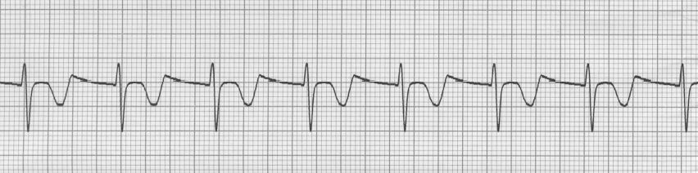

Rate: ____________________________________
Rhythm: ____________________________________
P waves: ____________________________________
PR Interval: ____________________________________
QRS: ____________________________________

Dx: ____________________________________

ECG #7
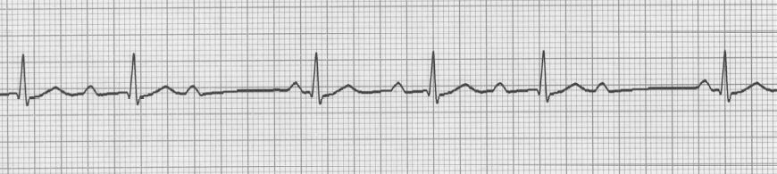

Rate: ____________________________________
Rhythm: ____________________________________
P waves: ____________________________________
PR Interval: ____________________________________
QRS: ____________________________________

Dx: ____________________________________

ECG #8
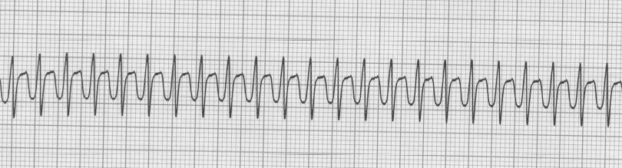

Rate: ____________________________________
Rhythm: ____________________________________
P waves: ____________________________________
PR Interval: ____________________________________
QRS: ____________________________________

Dx: ____________________________________________

ECG #9
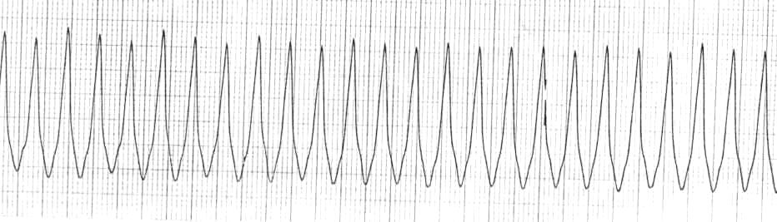

Rate: ____________________________________
Rhythm: ____________________________________
P waves: ____________________________________
PR Interval: ____________________________________
QRS: ____________________________________

Dx: ____________________________________________

ECG #10
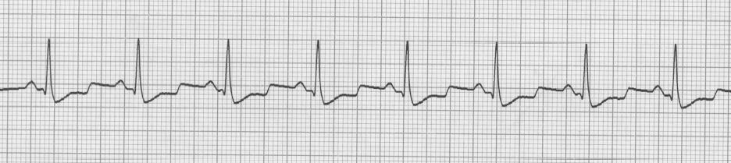

Rate: ____________________________________
Rhythm: ____________________________________
P waves: ____________________________________
PR Interval: ____________________________________
QRS: ____________________________________

Dx: _____________________________________

ECG #11
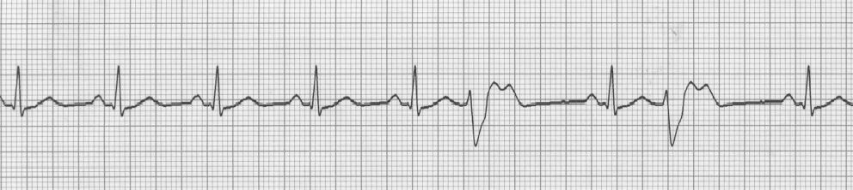

Rate: ____________________________________
Rhythm: ____________________________________
P waves: ____________________________________
PR Interval: ____________________________________
QRS: ____________________________________

Dx: ____________________________________________

ECG #12
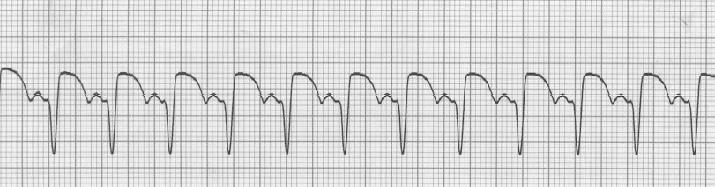

Rate: ____________________________________
Rhythm: ____________________________________
P waves: ____________________________________
PR Interval: ____________________________________
QRS: ____________________________________

Dx: ____________________________________

ECG #13
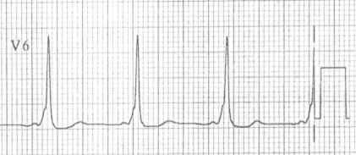

Rate: ____________________________________
Rhythm: ____________________________________
P waves: ____________________________________
PR Interval: ____________________________________
QRS: ____________________________________

Dx: ____________________________________

ECG #14
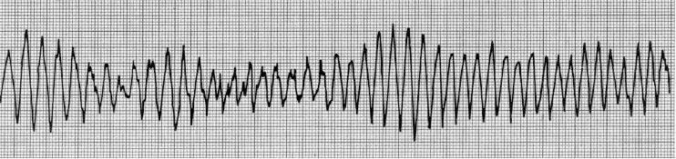

Rate: ____________________________________
Rhythm: ____________________________________
P waves: ____________________________________
PR Interval: ____________________________________
QRS: ____________________________________

Dx: ____________________________________________

ECG #15
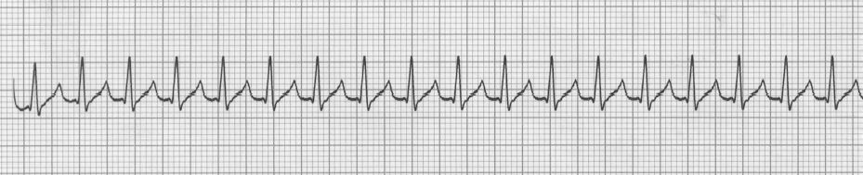

Rate: ____________________________________
Rhythm: ____________________________________
P waves: ____________________________________
PR Interval: ____________________________________
QRS: ____________________________________

Dx: ____________________________________

ECG #16
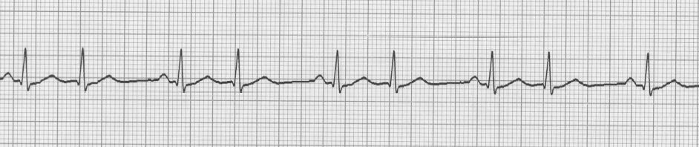

Rate: ____________________________________
Rhythm: ____________________________________
P waves: ____________________________________
PR Interval: ____________________________________
QRS: ____________________________________

Dx: ____________________________________

ECG #17
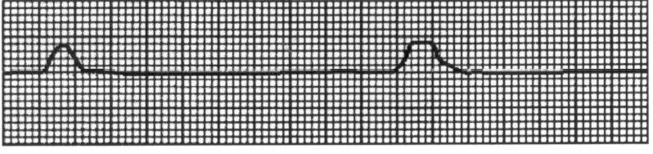

Rate: ____________________________________
Rhythm: ____________________________________
P waves: ____________________________________
PR Interval: ____________________________________
QRS: ____________________________________

Dx: ____________________________________________

ECG #18
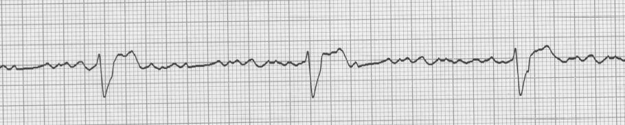

Rate: ____________________________________
Rhythm: ____________________________________
P waves: ____________________________________
PR Interval: ____________________________________
QRS: ____________________________________

Dx: ____________________________________________

ECG #19
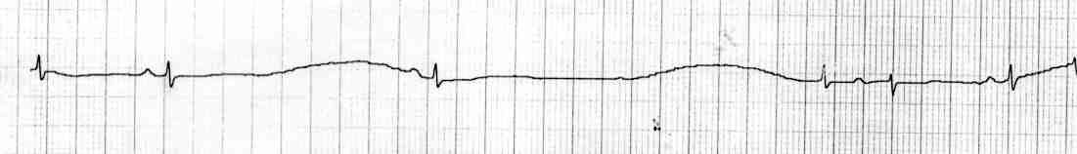

Rate: ____________________________________
Rhythm: ____________________________________
P waves: ____________________________________
PR Interval: ____________________________________
QRS: ____________________________________

Dx: ____________________________________________

ECG #20
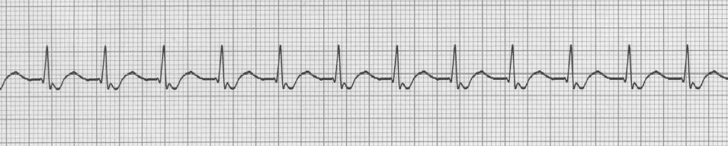

Rate: ____________________________________
Rhythm: ____________________________________
P waves: ____________________________________
PR Interval: ____________________________________
QRS: ____________________________________

Dx: ____________________________________________

ECG #21
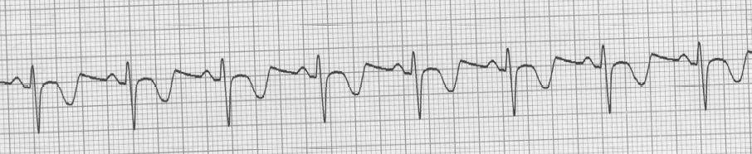

Rate: ____________________________________
Rhythm: ____________________________________
P waves: ____________________________________
PR Interval: ____________________________________
QRS: ____________________________________

Dx: ____________________________________

ECG #22
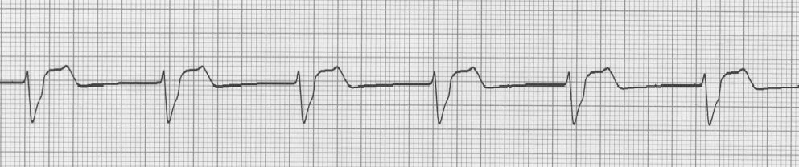

Rate: ____________________________________
Rhythm: ____________________________________
P waves: ____________________________________
PR Interval: ____________________________________
QRS: ____________________________________

Dx: ____________________________________

ECG 23
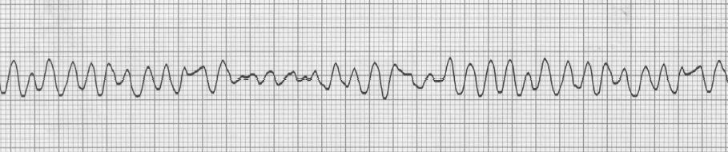

Rate: ____________________________________
Rhythm: ____________________________________
P waves: ____________________________________
PR Interval: ____________________________________
QRS: ____________________________________

Dx: ____________________________________

ECG #24
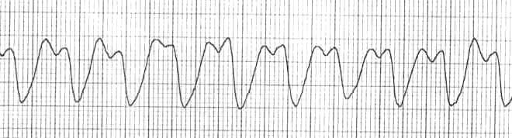

Rate: ____________________________________
Rhythm: ____________________________________
P waves: ____________________________________
PR Interval: ____________________________________
QRS: ____________________________________

Dx: ____________________________________

ECG #25
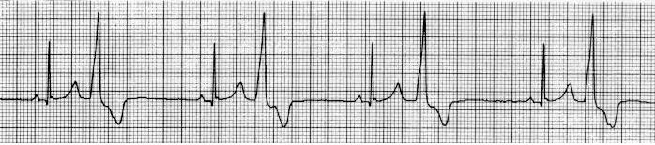

Rate: ____________________________________
Rhythm: ____________________________________
P waves: ____________________________________
PR Interval: ____________________________________
QRS: ____________________________________

Dx: ____________________________________

ECG #26
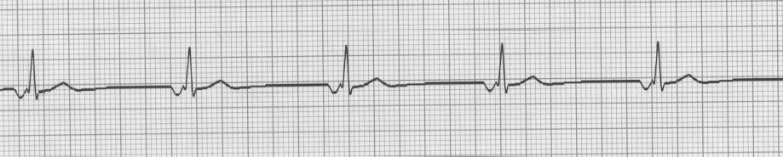

Rate: ____________________________________
Rhythm: ____________________________________
P waves: ____________________________________
PR Interval: ____________________________________
QRS: ____________________________________

Dx: ____________________________________

ECG #27
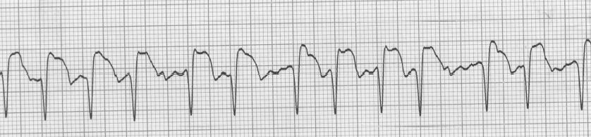

Rate: ____________________________________
Rhythm: ____________________________________
P waves: ____________________________________
PR Interval: ____________________________________
QRS: ____________________________________

Dx: ____________________________________

ECG 28
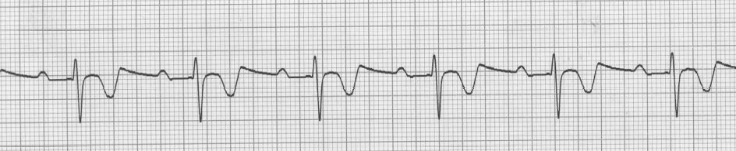

Rate: ____________________________________
Rhythm: ____________________________________
P waves: ____________________________________
PR Interval: ____________________________________
QRS: ____________________________________

Dx: ____________________________________

ECG #29
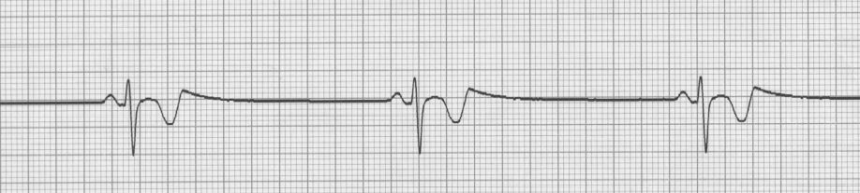

Rate: ____________________________________
Rhythm: ____________________________________
P waves: ____________________________________
PR Interval: ____________________________________
QRS: ____________________________________

Dx: ____________________________________

ECG # 30

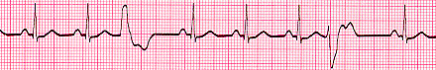

Rate: ____________________________________
Rhythm: ____________________________________
P waves: ____________________________________
PR Interval: ____________________________________
QRS: ____________________________________

Dx: ____________________________________

ECG # 31

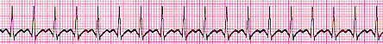

Rate: ____________________________________
Rhythm: ____________________________________
P waves: ____________________________________
PR Interval: ____________________________________
QRS: ____________________________________

Dx: ____________________________________

ECG # 32

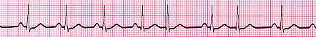

Rate: ____________________________________
Rhythm: ____________________________________
P waves: ____________________________________
PR Interval: ____________________________________
QRS: ____________________________________

Dx: ____________________________________

ECG # 33

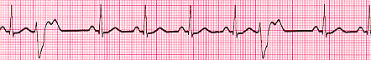

Rate: ____________________________________
Rhythm: ____________________________________
P waves: ____________________________________
PR Interval: ____________________________________
QRS: ____________________________________

Dx: ____________________________________

ECG # 34

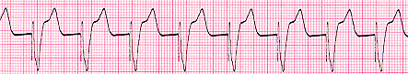

Rate: ____________________________________
Rhythm: ____________________________________
P waves: ____________________________________
PR Interval: ____________________________________
QRS: ____________________________________

Dx: ____________________________________

ECG # 35

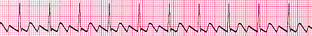

Rate: ____________________________________
Rhythm: ____________________________________
P waves: ____________________________________
PR Interval: ____________________________________
QRS: ____________________________________

Dx: ____________________________________

ECG # 36

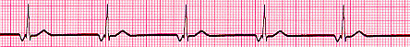

Rate: ____________________________________
Rhythm: ____________________________________
P waves: ____________________________________
PR Interval: ____________________________________
QRS: ____________________________________

Dx: ____________________________________

ECG # 37

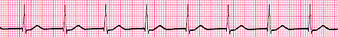

Rate: ____________________________________
Rhythm: ____________________________________
P waves: ____________________________________
PR Interval: ____________________________________
QRS: ____________________________________

Dx: ____________________________________

ECG # 38

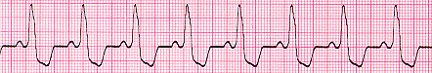

Rate: ____________________________________
Rhythm: ____________________________________
P waves: ____________________________________
PR Interval: ____________________________________
QRS: ____________________________________

Dx: ____________________________________

ECG # 39

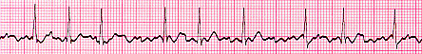

Rate: ____________________________________
Rhythm: ____________________________________
P waves: ____________________________________
PR Interval: ____________________________________
QRS: ____________________________________

Dx: ____________________________________

ECG # 40

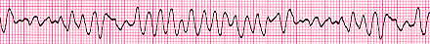

Rate: ____________________________________
Rhythm: ____________________________________
P waves: ____________________________________
PR Interval: ____________________________________
QRS: ____________________________________

Dx: ____________________________________

ECG # 41

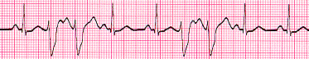

Rate: ____________________________________
Rhythm: ____________________________________
P waves: ____________________________________
PR Interval: ____________________________________
QRS: ____________________________________

Dx: ____________________________________

Ecg # 42

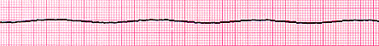

Rate: ____________________________________
Rhythm: ____________________________________
P waves: ____________________________________
PR Interval: ____________________________________
QRS: ____________________________________

Dx: ____________________________________

ECG # 43

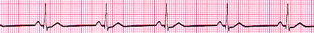

Rate: ____________________________________
Rhythm: ____________________________________
P waves: ____________________________________
PR Interval: ____________________________________
QRS: ____________________________________

Dx: ____________________________________

ECG # 44

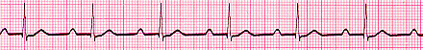

Rate: ____________________________________
Rhythm: ____________________________________
P waves: ____________________________________
PR Interval: ____________________________________
QRS: ____________________________________

Dx: ____________________________________

ECG # 45

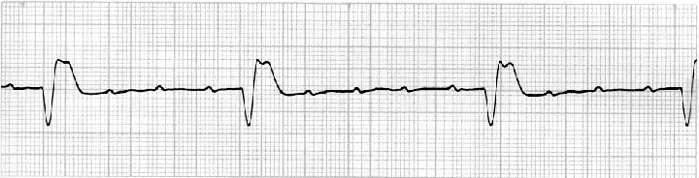

Rate: ____________________________________
Rhythm: ____________________________________
P waves: ____________________________________
PR Interval: ____________________________________
QRS: ____________________________________

Dx: ____________________________________

ECG # 46

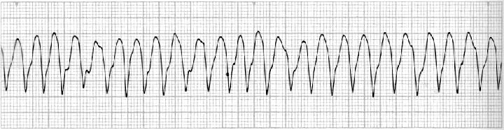

Rate: ____________________________________
Rhythm: ____________________________________
P waves: ____________________________________
PR Interval: ____________________________________
QRS: ____________________________________

Dx: ____________________________________

ECG # 47

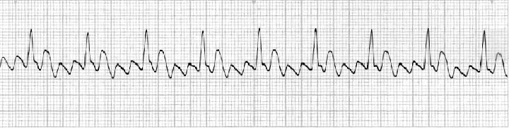

Rate: ____________________________________
Rhythm: ____________________________________
P waves: ____________________________________
PR Interval: ____________________________________
QRS: ____________________________________

Dx: ____________________________________

