EKG RHYTHMS---- From Order to Chaos------
Strip | Rate | Rhythm | P Waves | PRI | QRS | Discussion
Normal Sinus Rhythm  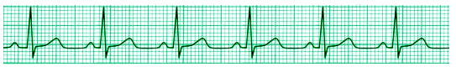 | 60-  100 | REG | +  ↑  ~  1:1 QRS | 0.12-  0.20  Sec  = | <0.12  Sec,  =  ~ | To be ”Normal Sinus Rhythm” as opposed to “Sinus Rhythm,” must meet all criteria
Sinus Bradycardia  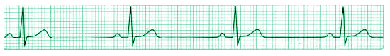 | < 60 | REG | +  ↑  ~  1:1 QRS | 0.12-  0.20  Sec  = | <0.12  Sec,  =  ~ | -Etiology? –  -Symptoms?  -Atropine IV  (Symptomatic  Bradycardia)  -Consider Pacemaker
Sinus Tachycardia  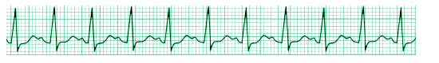 | 101-  150 | REG | +  ↑  ~  1:1 QRS | 0.12-  0.20  Sec  = | <0.12  Sec,  =,  ~ | Search for and eliminate source, if possible  Consider:  Pain  Anxiety  Hypovolemia  Drugs
Supraventricular Tachycardia (SVT)  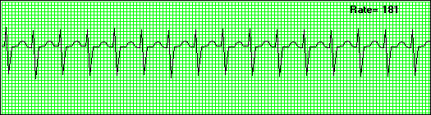 | >150  + | REG | Typically  Cannot  See (“Buried” in the QRS) | N/A | <0.12  Sec,  =  ~ | NARROW COMPLEX TACHYCARDIA:  -Vagal Maneuvers;  -Adenosine IVP;  -Synchronized Cardioversion
Atrial Fibrillation  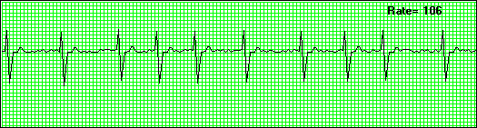 | Varies | IRREG | NO | N/A | <0.12  sec | Chronic versus new onset;  “Controlled versus uncontrolled; frequently (in chronic) goal is to keep rate under 100 bpm  -Digoxin  -Synchronized Cardioversion  -Coumadin

Strip | Rate | Rhythm | P Waves | PRI | QRS | Discussion
Atrial Flutter  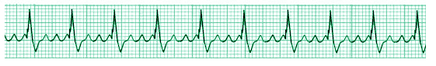 | Varies | REG  Or IRREG | NO---  “F”  Waves  (Saw  Tooth) | N/A | <0.12  Sec,  =’  ~ | Patient may alternate between a-flutter and a-fib; may be regular or irregular; typically classified by f-wave distribution; i.e., this strip is 3:1—there are 3 f-waves per QRS complex.  --Cardioversion; Digoxin; others….
Ventricular Tachycardia  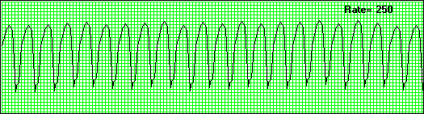 | > 100-  200 | REG | N/A | N/A | >0.12  Sec,  =,  ~  “Wide & Bizarre” | 2 Types:  --With or Without a Pulse  (See PVC’s for more discussion)  -CPR (No Pulse)  -Synchronized Cardioversion  -Lidocaine or amiodarone IV  -ACLS!
Ventricular Fibrillation (Coarse)  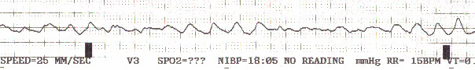 | 0 | NONE | N/A | 0.12-  0.20  sec | NONE | -CPR  -IMMEDIATE DEFIBRILLATION  -ACLS  -Epinephrine, others
Ventricular Fibrillation (Fine)  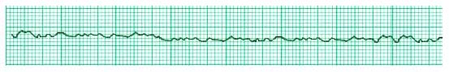 | 0 | NONE | N/A | N/A | NONE | -CPR  -IMMEDIATE DEFIBRILLATION  -ACLS  -Epinephrine, others
Asystole  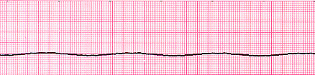 | 0 | NONE | NO | N/A | NONE | -Check the Leads & Patient !  -CPR & ACLS  -NON-Shockable Rhythm  -Source??  -Epinephrine IV  -Atropine IV

Strip | Rate | Rhythm | P Waves | PRI | QRS | Discussion
Pulseless Electrical Activity (PEA)  IMPORTANT: THIS RHYTHM MAY LOOK LIKE ANY RHYTHM THAT SHOULD HAVE A PULSE ! The approach in treatment of PEA is to treat the underlying cause.  “6Hs and 6Ts”:  - Hypovolemia  - Hypoxia  - Hydrogen ions (Acidosis)  - Hypothermia  - Hyperkalemia or Hypokalemia  - Hypoglycemia  - Tablets or Toxins (Drug overdose)  - Tamponade, Cardiac  - Tension pneumothorax  - Thrombosis (Myocardial infarction)  - Thrombosis (Pulmonary embolism)  - Trauma (Hypovolemia from blood loss) | Varies | REG  Or IRREG | Present,  Non-Present,  Variable | Variable | Variable | PATIENT IS UNRESPONSIVE, WITH NO PULSE  IF RHYTHM ON MONITOR IS ASYSTOLE, VENTRICULAR FIBRILLATION, OR VENTRICULAR TACHYCARDIA, THEN (BY DEFINITION) THEY CANNOT BE PEA, BECAUSE THESE RHYTHMS ARE NOT (USUALLY) ASSOCIATED WITH A PULSE..  Treated as Asystole:  Search for Source  Epinephrine IV  Atropine IV (Possible)
Polymorphic Ventricular Tachycardia (Toursades des Pointes)  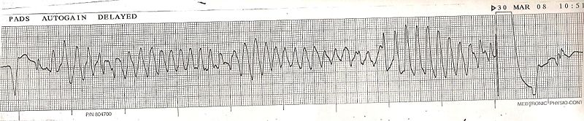 | > 100-  200 | IRREG | N/A | N/A | >0.12  sec | “Twist Around the Point”  “Typical medications for Ventricular Tachycardia (Monomorphic V-Tach) will make it worse.  --DEFIBRILLATE  --Magnesium IV

Strip | Rate | Rhythm | P Waves | PRI | QRS | Discussion
Junctional Rhythms  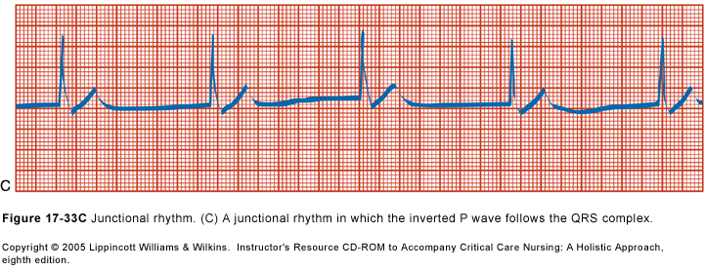 | Varies  (AV  Junct  Rate=  40-60) | REG | Absent,  Inverted,  Biphasic,  or retrograde  (after the QRS) | 0 –  <  0.12 sec | < 0.12  Sec,  =,  ~ | AV Node or AV Junctional area has taken over as “pacemaker,” so no P wave, or “different p-wave  -Junctional Rhythm  -Accelerated Junctional Rhythm  -Junctional Tachycardia
First Degree A-V Block  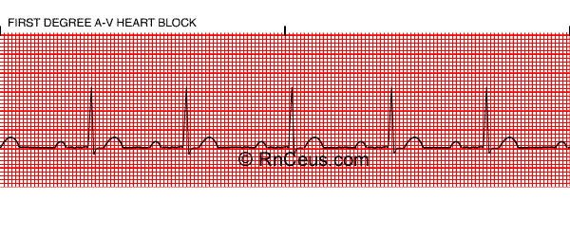 | Varies | REG | +  ↑  ~  1:1 QRS | >  0.20  Sec  = | < 0.12  Sec,  =,  ~ | -Can be a normal variant  -Can be benign, or a precursor of “bad things to come…”  -Check previous EKG’s  -Continue to monitor patient
Second Degree A-V Block, Mobitz I (Wenkebach)  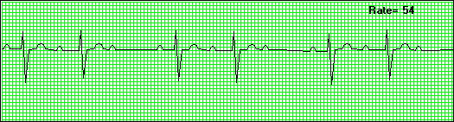 | <  60  (usual) | IRREG | +  ↑  ~  NOT  1:1 QRS | Vary  *  See  Disc. | NONE | -PRI gradually lengthens until a QRS complex is ‘dropped.’ --Repetitive pattern  -athletes; post-valvular surgery, MI, Drug-induced: beta-blockers, CA+ Channel blockers, amiodarone, lidocaine, digoxin
Second Degree A-V Block, Mobitz II  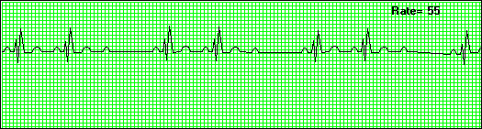 | <  60  (usual) | NONE | N/A | N/A | NONE | Mobitz II block most commonly is caused by an acute myocardial infarction (anterior or inferior). Drug-induced etiologies can also occur (as above)
Third Degree A-V Block  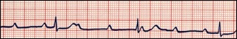 | 20-40 | NONE | +  ↑  ~  NOT 1:1 | N/A | NONE | -Emergency  Pacemaker  (Drug induced: as above)  Infection  -Hyperkalemia  -more

Strip | Rate | Rhythm | P Waves | PRI | QRS | Discussion
-----------“INDIVIDUAL” ECTOPY / ECTOPIC BEATS---------------
Premature Ventricular Contractions (PVC’s) (Unifocal)  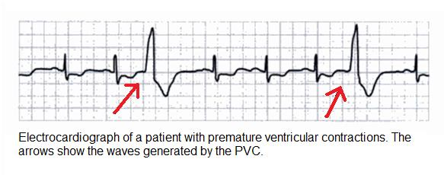 | Varies | Irreg | None preceding the PVC | N/A | “Wide  & Bizarre” | -PVC’s MAY be benign.  -May be a sign of ventricular irritability due to surgery, injury,
Premature Ventricular Contractions (PVC’s) (Bigeminy)  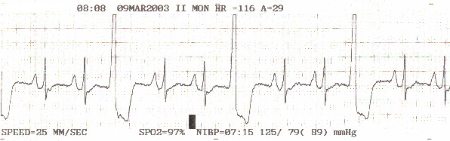 | Varies | Irreg | None preceding the PVC | N/A | “Wide  & Bizarre” | Such as in an MI; may occur due to electrolyte imbalances; toxins, etc.  -Generally speaking, the more PVC’s per minute, the worse it is.
Premature Ventricular Contractions (PVC’s) (Multifocal) (Frequent)  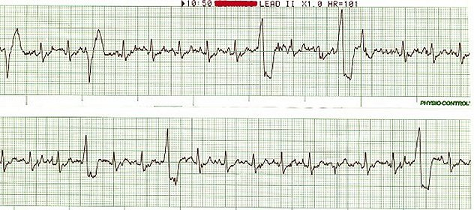 | Varies | Irreg | None preceding the PVC | N/A | “Wide  & Bizarre” | -Greater than 6 PVC’s per minute is frequently used as criteria to treat with antiarrhythmics.  -Increasing frequency of PVC’s, particularly if appearing in couplets, triplets, salvos, or “runs of V-Tach”
Premature Ventricular Contractions (PVC’s) ( Couplets)  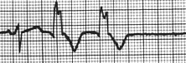 | Varies | Irreg | None preceding the PVC | N/A | “Wide  & Bizarre” | Lidocaine IVP  Lidocaine Infusion  Amiodarione IVP  Others…

Strip | Rate | Rhythm | P Waves | PRI | QRS | Discussion
Premature Ventricular Contractions (PVC’s) (Triplets, Salvos)  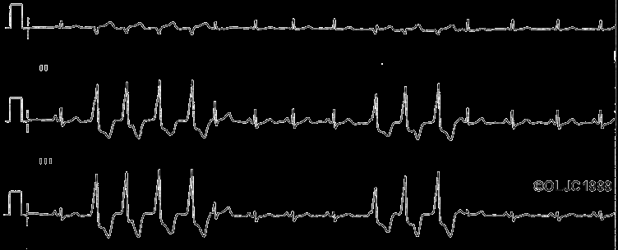 | Varies | IRREG | None preceding the PVC | N/A | < 0.12  sec | Sign of “Increased Ventricular Irritability= greater chance of V-Tach & Cardiac Arrest  Lidocaine IVP  Lidocaine Infusion  Amiodarione IVP  Others…
Multi Focal PVC’s  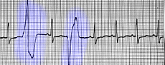 | Varies | IRREG | None preceding the PVC | N/A | < 0.12  sec | As above
Premature Junctional Contraction / Premature Atrial Contraction  (PJC) (PAC)  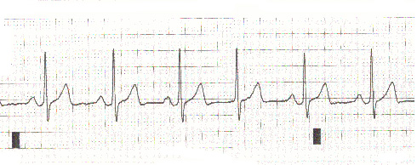 | Varies | IRREG | None preceding the PAC or PJC | N/A | NONE | Typically benign  If this is a change, be vigilant for other changes!
Paced Rhythms  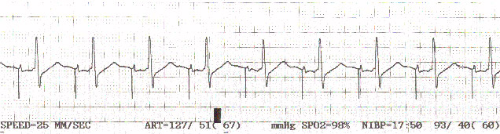 | Varies | REG  Or  IRREG | May or may not be present | N/A | NONE | Look for the “Pacer Spike” or “Spikes” before the QRS Complex.  -100% Paced  -Demand Paced  -% Paced / % Captured  *AICD
Artifact  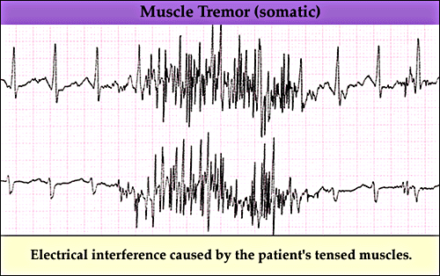 | N/A | IRREG | N/A |  |  | --If continues, Search for source & eliminate;  --Wait for it to go away!  --60 cycle = machinery  “Noise”

