Chest Tubes

1- What are chest tubes used for?
2- Where exactly is a chest placed?
3- How does the three-chamber system work?
4- Can suction be bad for the patient?
5- What is the difference between exudate and transudate, and why do we care?
6- What is an effusion?
7- How are effusions treated?
8- When should a chest tube for effusions be removed?
9- What is pleurodesis?
10- How are malignant effusions treated?
11- What is streptokinase used for when it is given through a chest tube?
12- What is empyema?
13- What exactly is an air leak?
14- How can you tell if the chest tube port is out of the chest?
15- How can this be fixed?
16- Are air leaks good or bad?
17- Would that be a bad situation?
18- What is the black button on top of the pleurevac for?
19- What is tube “stripping”?
20- How could I tell if a patient were developing a tension situation in her chest?
21- What is a pulsus paradoxus?
22- Should you ever clamp a chest tube?
23- What if the chest tube gets pulled out by mistake?
24- What is “water seal”?
25- What is subcutaneous emphysema, and what does it have to do with chest tubes?

Please keep the following in mind as you read this FAQ: the information written here is meant to reflect the knowledge and experience gained over “too many” years of ICU nursing at the “trenches” level. My idea is to provide useful information for the newer nurse at the bedside, the kind of information that a preceptor would pass on to a newer staff member in orientation on the unit. It is not meant to be any kind of “official” reference, and it is certainly not meant to be the final word on any question of any kind! The goal is comprehension. If you see an error, or think something isn’t clear, let me know, and we’ll change it right away. I think that these files will be much more useful if everybody gets to contribute. Thanks!

Copyright materials used with permission of the
author and the University of Iowa's Virtual Hospital: www.vh.org.

Thanks Iowa! (“Is this heaven?”, “No, it’s Virtual Iowa…”).

1- What are chest tubes used for?

Chest tubes are long, semi-stiff, clear plastic tubes that are inserted into the chest, so that they can drain collections of fluids or air from the space between the pleura. If the lung has been compressed because of this collection, the lung can then re-expand.

Some reasons for inserting a chest tube:

Pneumothorax: a collection of air in the pleural space. These can happen spontaneously: I saw a young man walk into the ER once, who “just didn’t feel right” - he had a nearly completely collapsed right lung. Pneumos can occur after central line insertion, after chest surgery, after trauma to the chest, or after a traumatic airway intubation. Important to remember: if the air continues to collect in the chest, the pressure in that collection can rise, and push the whole mediastinum over to the other side - this is called a “tension pneumothorax”, and is definitely life-threatening. Call the surgeon.

http://www.henryfordhealth.org/18652.cfm

Hemothorax: a collection of blood in the pleural space, maybe from surgery, maybe from a traumatic injury.

This is actually a hemo-pneumo-thorax: blood and air…

http://www.henryfordhealth.org/18145.cfm

Here’s a really nice picture from the University of Iowa’s Virtual Hospital, used with permission. See the shifted mediastinum? – the trachea’s shoved over to the right.

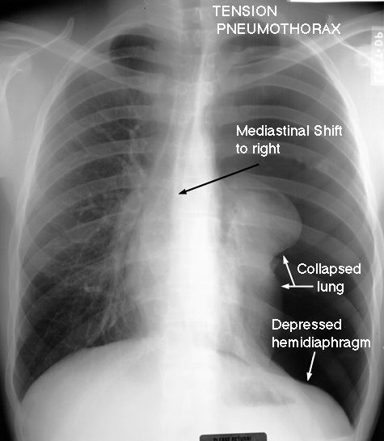

Pus can collect in the pleural space - “empyema”.

Fluid, usually serous, maybe from CHF, sometimes from a tumor process, will collect between the pleura - “pleural effusion”.

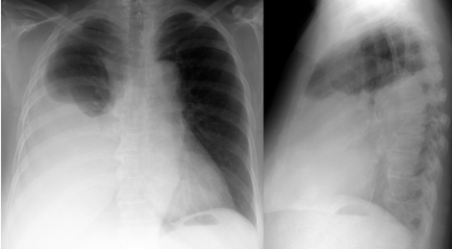

Another nice picture from Iowa – big effusion there on the right! (No, Ralph – the patient’s right!)

2- Where exactly is a chest tube placed?

The chest tube is inserted by a surgeon, usually thoracic, but sometimes someone from the general surgical service. The entry point is the fourth or fifth intercostal space, on the mid-axillary line, which is pretty close to the point at which you level a line transducer. The tube is inserted towards the collection: sometimes up and in front, or up and in back, or wherever the collection lies.

3- How does the three-chamber system work?
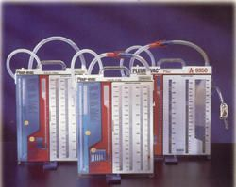

We use a device called a pleurevac, a large plastic box with what seems like fourteen separate compartments in it - actually the ideas behind it are not hard to grasp. The box actually imitates an old system that was invented to drain chest tubes, which used three chambers - they were actually glass bottles held by a metal rack - in series. (I remember those glass setups - I must be getting really old.)

http://www.proasepsis.com/productos.html

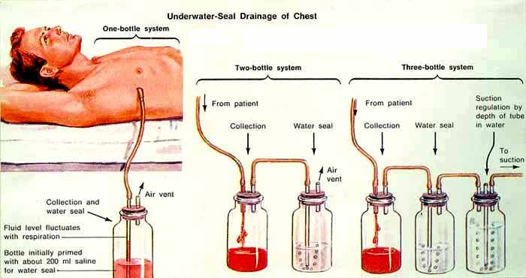

http://home.ewha.ac.kr/~chestsg/dong/poster/99/2-08.jpg

Wow – look what you can find if you hunt around on the web…the patient’s looking very relaxed! “Chest tube placement in tanning booth…”

So – first, take a look at the single-bottle setup there on the left of the picture.. what I was taught to call an “air trap“, or “air leak chamber”. The idea here is pretty simple: suppose you had a chest tube freshly inserted into your patient, with the end hanging loose. The patient could suck air 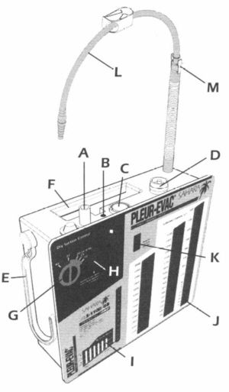directly into her chest through the tube if that distal end wasn’t controlled somehow - maybe with a one-way flapper on the end? So that the air the patient pushed out of her chest would go out, but none would get sucked back in?

How about putting the distal end of the tube into a cup of water? Or a bottle of water? That would work as a one-way valve, unless the patient were able to breathe in hard enough to suck up the water - how about putting the bottle of water at the end of a long tube, far away from the patient - so she couldn’t suck the water back? That’s how the air trap works. The trap is filled with water at some distance from the patient - look at how long the drainage tube is on a pleurevac sometime - and only lets air out, not back in. Bubbles moving through the trap means that the patient has an “air leak”, and that the tube is draining air properly (that’s what it’s supposed to mean - more on troubleshooting below.)

This isn’t quite the one we use, but it’s close enough to point arrows at:

Air coming out of the patient will bubble out here, which is the defninition of an “air leak”. No bubbles, no leak. First bottle.

Here’s where the drainage comes out. Second bottle.

Here’s where the water column goes. Third bottle.

http://www.auh.dk/akh/afd/afd-n/intensiv/procedurer/bilag/bil11.htm

So a single-chamber setup would work if the only thing comng out of the patient’s chest was air – what if there’s fluid in there that needs draining, too? Time for a second bottle.

In the multi-bottle setups above, the second chamber is the air trap, while the first collects fluid drained from the patient: blood, or serous fluid from the pleural space. You may be surprised at how rapidly these can fill up in certain situations - for example, tumor-related effusions can drain more that a liter - or two liters – in a day. You’ll have to change the pleurevac when it’s full. This is the only time that we routinely clamp a chest tube - remove the clamp after the boxes are switched. Don’t forget!

Hey – here’s an idea: what about adding suction to this arrangement? It only makes sense that it would help drain the patient’s chest if you could gently suck air and fluid out of her pleural space, right? But if you hook up suction from the wall, even with a regulator, you might pull too hard…now you need the third bottle. To deliver very precise suction, we use the weight of a measured column of water, which shouldn’t change as long is it’s topped up now and then.

The regulated wall suction is applied to a partly-water-filled plastic column in the pleurevac box, above the water level - and the weight of the water acts as a suction limiter. No matter how hard the wall suction pulls, the actual suction delivered to the patient is only as hard as the amount required to pull air out past that fixed weight of water. Any suction above that just pulls in air from outside the box, through a vent. The incoming air bubbles through the column, which is what makes all the noise you hear when the box is hooked up to the wall suction. All you need to apply is enough to make it bubble – more than that just makes noise, and makes the water evaporate.
Oh yes: fill a pleuevac up with sterile water instead of normal saline. As saline evaporates, it will actually (a surgeon told me once), leave salt crud on the sides of the box chambers…

4- Can suction be bad for the patient?

Obviously, you need to control the amount of suction applied to the patient. Make sure you have your pleurevac set up correctly. The surgeon who inserts the tube should order a specific water level in the control column - we usually fill it to 20 cm, but sometimes they order less.

5- What is the difference between transudate and exudate, and why do we care?

“Transudates” and “exudates” are descriptive names for types of fluids that can collect in the pleural space. Transudates you might think of as “thinner” - they often result from CHF, and you might think of them as more “watery”, being “sweated” into the pleural space when a patient is “wet”. Exudates might be thought of as “thicker” - they contain more protein, and usually result from some kind of inflammatory process. They can also be a result of tumor processes - patients with lung Ca or pleural mets often show up with exudative fluid collections. You tell the difference by sending thoracentesis specs to the lab.

6- What is an effusion?

Transudates and exudates are types of effusions - the idea being that the collections of fluid are “sweated” from the lung. Recurrent effusions can be a real problem for a patient who is dealing with a long-term illness, but as long as the patient has a reasonable hope for living a while yet, there is good reason to treat the effusion, either with treatment for underlying CHF, or for an underlying tumor process, or for whatever else is causing the problem.

7- How are effusions treated?

In the short term, with a chest-tube. Some effusions related to CHF can be treated with diuresis - the idea is that decreasing the amount of the water component in the blood will cause the effusion to be re-absorbed. If the effusion is large enough to produce respiratory distress, or tension symptoms, you obviously would think more about inserting a chest tube.

8- When should a chest tube for effusions be removed?

“When it’s safe to to do so.” This sounds stupid until you stop and think about the underlying reason why the tube was inserted in the first place. Is the effusion just going to re-collect after the original one is drained? Maybe something needs to be done to stop the effusion from recurring, like “pleurodesis”.

9- What is pleurodesis?

Pleurodesis is a technique of instilling some substance or other into the pleural space through the chest tube, which is then supposed to “weld” the pleura together by scarring them, preventing the re-collection of fluid between them. This doesn’t sound like it would be a very pleasant idea, but it works pretty well for some situations. I remember the old days, when the scarring agents used to cause a lot of pain - I’m sure that they weren’t chosen to be painful, but they were - let’s forget about those… Nowadays they use sterile talcum powder, which comes up from the pharmacy in large sterile syringes and looks strange - apparently it works very well.

10- How are malignant effusions treated?

Talcum powder is instilled into the pleural space, right through the chest tube. Then the patient gets rolled around into different positions every whichy-way so that the scarifying agent gets distributed everywhere.

11- What is streptokinase used for when it is given through a chest tube?

Sometimes you’ll see narrow-gauge chest tubes inserted instead of the large clear ones, and because they’re narrow, they get can plugged up with fibrin, which stops the drainage. The tube in this case is usually rigged with a stopcock between the end of the tube and the connector to the pleurevac - the team will instill a dose of streptokinase through the stopcock and into the patient through the chest tube, let it sit for half an hour, and then turn the stopcock back to drain. The dose I see given is 250,000 units.

Strepto is also injected if the patient has a “loculated” effusion, which means that it’s managed to become surrounded by a fibrin membrane. The drug breaks up the membrane and lets the effusion get to the tube for drainage.

12- What is empyema?

This is a collection of pus in the pleural space, or in a big abscess space in the lung tissue itself.
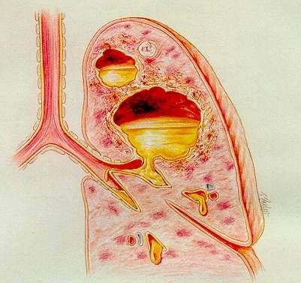

Feh! Pus can collect in large enough quantities to compress the lung, and certainly will act as a septic “focus” until it’s drained. Empyema can result from chest trauma - say, a gunshot or knife wound - or necrotizing pneumonia, or any other process that puts bacteria into the chest.

And you were wondering why your patient was on pressors? Actually, that’s a good question: new ICU nurses, why might this situation make your patient need pressors? Look one paragraph up for the hint.

http://www.koreacna.or.kr/cuecom/diseasecare/respiratory/07.respiration-empyema.htm

13- What exactly is an “air leak”?

The idea of using chest tubes to remove air from the pleural cavity means that there has to be some way to tell that air is actually coming out. The smaller bubble chamber in the pleurevac shows an air leak very simply - if there are bubbles coming through it, then air is coming down the tube and being evacuated. It’s important to remember that this does not mean automatically that air is coming out of the chest. If there’s a leak in the tubing, or if a chest tube suction port (the openings along the lumen of the tube inside the chest that draw in the air and fluid for drainage) is outside of the chest wall, then air will be sucked in there - instead of being pulled out of the chest. So bubbles are a good sign, but you have to check everything else too.

14- How can you tell if the chest tube port is out of the chest?

Sometimes you’ll suddenly hear a new sound in your room. Hunting around, you may find that your patient’s chest tube has inadvertently taken a yank - and it’s whistling at the insertion site. A port has come outside the skin, and it’s continuously sucking in air from the atmosphere around it. You can put your stethoscope on the dressing over the site if you’re suspicious, and you’ll hear it clearly there.

Take a look at this picture – one of these chest tubes isn’t quite right. See the radio-opaque lines going along the tubes? Look at the one on the patient’s left. See the break in the line? That’s the drainage opening. Nicely inside the chest? So what about the one on the other side?

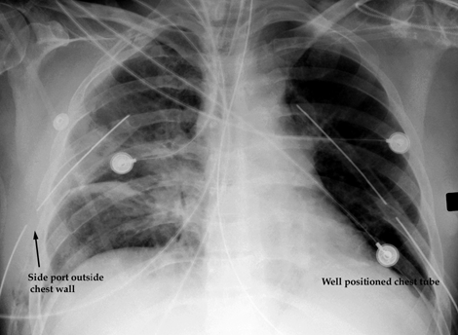

15- How can this be fixed?

If you take the site dressing down, you can wrap the port with sterile vaseline gauze and apply an occlusive dressing, but usually this situation means that the tube will need to be replaced. You’ll also need a stat x-ray - air may be dangerously re-accumulating in the chest!

16- Are air leaks good or bad?

It depends on the situation. (Everything always depends on the situation!) If a patient has a chest tube put in for a pneumothorax, then at least initially an air leak is a very good thing - because you certainly want that air out of there. If you don’t see bubbles coming out through the air leak chamber after a tube is placed for a pneumo - then you may have a non-functioning chest tube on your hands; it might not be in the right place. Get a look with the team at the followup x-ray immediately to see if the pneumo has shrunk at all - if not, the patient may need another tube put in. Same thing is true for a number of postop situations involving chest surgery: open lung biopsies, lobectomies, pneumonectomies - all these leave an area of lung tissue that will leak air into the pleural space until they heal, and so require chest tubes to get rid of that air. So air leaks in those cases are also good. But say a patient still had an air leak two weeks after an open lung biopsy - what then?

17- Would that be a bad situation?

Probably - either the chest tube is leaking and sucking air in around itself somewhere - which means it isn’t working, and ought to be pulled anyhow, or it means that the patient is continuing to leak air into her chest - at this distance from the operation, this would mean that the tissue leaking the air into the pleural space isn’t healing - and in fact the patient may have developed a broncho-pleural fistula - meaning a semi-permanent tract connecting a bronchus and the pleural space.

This happens a lot with patients who need a lot of inspiratory pressure from the vent - say, pressure control of 25cm, and peep of 10cm, adding up to 35cm of forward pressure, being pushed into stiff, noncompliant lungs. That’s a lot. That much pressure means that air is being pushed pretty hard into those stiff lungs, and that air will be pushed out into the pleural space too, preventing it from healing closed. That healing won’t occur until that pressure can be mostly reduced, but the patient will lose a lot of ventilation because of the loss of volume through the fistula. A tough spot to be in. Time for permissive hypercapnia? Class – look that one up and get back to me…there will be no quiz, however. You are safe here in the FAQ!

18- What is the black button on top of the pleurovac for?

This is actually pretty important. Go back to the picture on page 5, and look at item D. See that button? The air leak chamber of a pleurevac, just like the first bottle of a drainage set, needs to be partly filled with water – that’s how the bubble-trap idea works, like putting the end of the chest tube in a cup of water, like a one-way valve. You put that water into that chamber when you set up the pleurevac, through a filling column that has an opening on the top of the box.

If you remember to look at the air leak chamber at various times during the course of your shift, you’ll notice that the water in it can sometimes rise up the filling column towards the top of the box. This usually happens if the patient is “pulling” very hard with inspiration - what they call “excess negative pressure”. Kind of like what high school teachers do…in other words, not only is the patient trying to pull in air through his airway, but also from the pleurevac itself, which actually he can’t, because that’s what the air leak chamber prevents, right? But the water in the trap chamber will rise up in the filling column after a while, and the air that’s trying to escape from the chest won’t be able to get out because of the increased weight of that column.

The resistance of the air trap, or leak chamber filled with water to the proper level, is only supposed to be tiny - about 2cm of water - not like the 20cm in the control column. So what you have to do is lower that column of water back down to the level indicated on the chamber - there’s a line marked on the box. Holding down the black button is the thing to do - hold the button down, and the column will slowly sink down towards the correct level - let go when it gets there. This problem also happens very often with tube “stripping”.
19- What is tube “stripping”?

Stripping is something people argue about a lot. The idea is that if a chest tube is “milked” every couple of hours after, say, a surgical procedure, then it won’t get plugged up by clots, which only makes sense, since if the tube gets plugged, then the air and fluid that it’s supposed to remove will not get removed, and a tension situation could develop in the chest. Definitely a bad thing.

But stripping and milking can pull too hard suction-wise on the chest cavity, possibly causing tissue injuries to the lung. Also a bad thing. So the only thing to do is to ask the surgeon what she wants done. If you’re instructed not to strip, watch carefully for signs that the chest tube is still working properly: draining air, fluid, or blood. If air were to stop coming out three hours postop a lobectomy - I’d page that surgeon right away.

20- How could I tell if a patient were developing a tension situation in her chest?

Sometimes the signs and symptoms are obvious, sometimes not. The first thing to do if you suspect this is to get the team to order a stat chest film - and then get it promptly read! Observing the patient, you might see hypotension, cyanosis, general signs of respiratory distress - maybe even tracheal deviation to the opposite side as the mediastinum gets pushed across the chest. If the patient has an arterial line, look for a pulsus paradoxus.

21- What is a pulsus paradoxus?

The idea here is that blood pressure varies as the patient inhales and exhales: literally goes up and down, maybe by 50 points, systolic. Maybe more. There are three main situations where you see this: tension pneumothorax, pericardial tamponade, and (maybe) severe hypovolemia.

Let’s take the first one, which is the relevant one here: what happens is that as the patient gets a breath, the intrathoracic pressure rises. The tension gets worse - maybe there’s already some mediastinal compression. The heart is squeezed tightly, and compressed, and literally doesn’t have room in the chest to pump.

This makes sense if you think about tension pneumothorax - a lung may go all the way down, and as the pressure in the chest continues to rise and rise, with every breath, the mediastinum gets pushed over harder and harder. So now when the patient gets a breath, the small addition of positive pressure (assuming they’re vented - in which case positive pressure happens on inspiration because the vent is pushing the air in) the heart gets squeezed just a little more, is able to move just a little less - can’t pump well - and the blood pressure drops.

When the patient exhales (on the vent, this is when intrathoracic pressure is released - after the breath is pushed in) - then the intrathoracic pressure drops again, and the heart is un-squeezed a bit, the heart can move just a little better, and the blood pressure rises again. This can sometimes be clearly seen if the patient has an arterial line - watch the tops of the blood pressure waves on the A-line as the breaths go in and out - if they drop more than 15-20 points per breath, you’ve got a “clinically significant” pulsus paradoxus - often a very clear classic sign of pneumothorax. Think about it - did the patient just have a central line put in…?

You can measure this by using the arterial line cursor - there is one there, although we hardly ever use it. Chase the wave tops up and down, measuring the distance between the tops at inspiration and the tops at expiration, and find the difference. You might see a dramatic change – in a severe situation, maybe a systolic of 150 dropping to 80.

Here’s a nice sample of a pulsus paradoxus showing up on an arterial-line waveform:

http://critcare.lhsc.on.ca/edu_briefs/jan7a00.html

See the pressures going upand down? ICU nurses: is this patient vented, or not? Try to calculate: is this pulsus greater than 20 points?

22- Should you ever clamp a chest tube?

Aside from changing the pleurevac, it sounds like a bad idea to me. If the pleurevac tubing comes disconnected from the chest tube itself, then I would clamp the tube only long enough to hook up another one, to prevent air from being sucked back into the chest. But only that long! Did the tube get contaminated?

23- What if the chest tube gets pulled out by mistake?

That’s what you keep vaseline gauze at the bedside for. You would slap that gauze right onto the site, (don’t really slap the patient, right?) and occlude the opening - you don’t want air going back into the patient’s chest – for the same reason why you’d (briefly!) clamp a chest tube in the question above. Again, you’d want to stat page a surgeon if the patient needed the tube back in, and get a CXR ordered right away.

24- What is “water seal”?

“Water seal” means that you’ve disconnected the wall suction line from the pleurevac (on purpose). Usually this is ordered when the air and/or fluid draining from the patient is assumed to be pretty much over and done with - several days after surgery - maybe not in the case of recurrent effusion - maybe a day or so after pleurodesis when you’d expect the drainage to have stopped. You’d want to watch carefully for signs of re-accumulating air or fluid in the chest - daily, or sometimes twice-daily x-rays will help determine this. It’s done as a maneuver when you’re thinking about pulling the tube after it’s served its’ purpose.

25- What is subcutaneous emphysema, and what does it have to do with chest tubes?

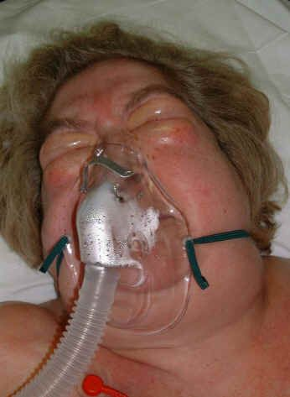

Subcutaneous emphysema is the collection of air in the tissues just under the skin – once you feel it, you’ll never forget it: as though Rice Krispies had been spread around under the patient’s skin. If a chest tube isn’t properly placed, or maybe if the site dressing isn’t airtight, air can leak into the tissue around the insertion site. Eventually it can track up and down the body, sometimes causing the neck and face to swell, sometimes threatening the airway. In that case the patient should be immediately assessed for intubation - there may be no time to waste! Correcting the position of the chest tube usually stops the leakage of air into the tissues, and the air itself is almost always very rapidly reabsorbed - a matter of several days at most, in my experience.

http://www.aic.cuhk.edu.hk/web8/chest_injuries.htm

Hard to tell which side it’s coming from – both eyes are certainly swollen, aren’t they? Is this patient really a little heavy-set, or is that air in her facial tissue? Actually, if her eyes look like that, it’s probably the second…

